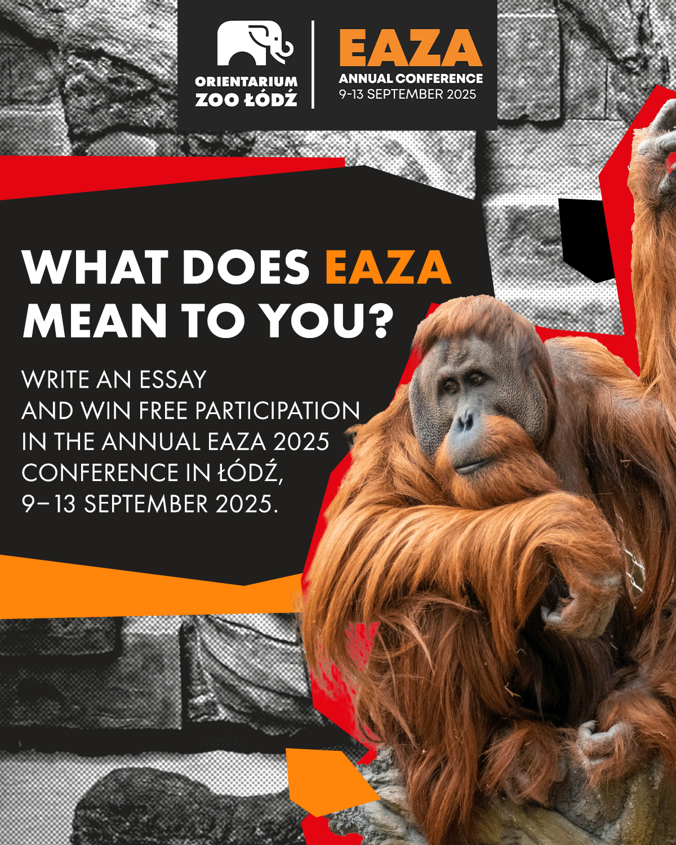

[Application Form](https://strapi.eaza.net/uploads/Application_Form_EAZA_2025_e7aada29ea.docx)

**Attention Zoo Professionals!**

Orientarium Zoo Łódź is excited to announce our competition:

**"What does EAZA mean to you?"**   
  
This is a fantastic opportunity for zoo employees across Europe to share their pride in and experience with being part of the EAZA community.

**What’s at Stake?** Winners will receive:

* Free participation in the EAZA 2025 conference
* Free accommodation

**Important Dates:**

* **Submission Deadline:** August 22, 2025 (11:59 PM)
* **Results Announcement:** August 29, 2025
* **EAZA 2025 Conference:** September 9-13, 2025 in Łódź, Poland

**Who Can Participate?**

* Employees of EAZA member zoos outside Poland with at least one year of experience.
* Submissions must include a response to the question, two letters of recommendation, and an application form.

**Submit your entries and any questions to:** [szkolenia@zoo.lodz.pl](mailto:szkolenia@zoo.lodz.pl)

Let’s celebrate our shared passion and commitment to wildlife conservation!

For more details, check out the full Competition Rules.

Happy writing and good luck!

[Application Form](https://strapi.eaza.net/uploads/Application_Form_EAZA_2025_e7aada29ea.docx)